# C Pointers

The **pointer in C language** is a variable, it is also known as locator or indicator that points to an address of a value.

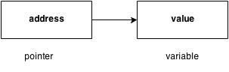

## **Advantage of pointer**

1) Pointer **reduces the code** and **improves the performance**, it is used to retrieving strings, trees etc. and used with arrays, structures and functions.

2) We can **return multiple values from function** using pointer.

3) It makes you able to **access any memory location** in the computer's memory.

## **Usage of pointer**

There are many usage of pointers in c language.

#### 1) Dynamic memory allocation

In c language, we can dynamically allocate memory using malloc() and calloc() functions where pointer is used.

#### 2) Arrays, Functions and Structures

Pointers in c language are widely used in arrays, functions and structures. It reduces the code and improves the performance.

## **Symbols used in pointer**

|  |  |  |
| --- | --- | --- |
| **Symbol** | **Name** | **Description** |
| & (ampersand sign) | address of operator | determines the address of a variable. |
| * (asterisk sign) | indirection operator | accesses the value at the address. |

## **Address Of Operator**

The address of operator '&' returns the address of a variable. But, we need to use %u to display the address of a variable.

1. #include <stdio.h>
2. #include <conio.h>
3. **void** main(){
4. **int** number=50;
5. clrscr();
6. printf("value of number is %d, address of number is %u",number,&number);
7. getch();
8. }

#### Output

value of number is 50, address of number is fff4

## **Declaring a pointer**

The pointer in c language can be declared using * (asterisk symbol).

1. **int** *a;//pointer to int
2. **char** *c;//pointer to char

## **Pointer example**

An example of using pointers printing the address and value is given below.

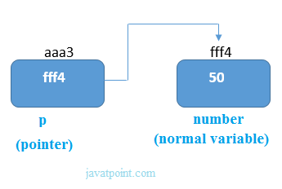

As you can see in the above figure, pointer variable stores the address of number variable i.e. fff4. The value of number variable is 50. But the address of pointer variable p is aaa3.

By the help of * (**indirection operator**), we can print the value of pointer variable p.

Let's see the pointer example as explained for above figure.

1. #include <stdio.h>
2. #include <conio.h>
3. **void** main(){
4. **int** number=50;
5. **int** *p;
6. clrscr();
7. p=&number;//stores the address of number variable
9. printf("Address of number variable is %x \n",&number);
10. printf("Address of p variable is %x \n",p);
11. printf("Value of p variable is %d \n",*p);
13. getch();
14. }

#### Output

Address of number variable is fff4

Address of p variable is fff4

Value of p variable is 50

## **NULL Pointer**

A pointer that is not assigned any value but NULL is known as NULL pointer. If you don't have any address to be specified in the pointer at the time of declaration, you can assign NULL value. It will a better approach.

int *p=NULL;

In most the libraries, the value of pointer is 0 (zero).

# C Pointer to Pointer

In C pointer to pointer concept, a pointer refers to the address of another pointer.

In c language, a pointer can point to the address of another pointer which points to the address of a value. Let's understand it by the diagram given below:

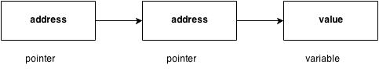

Let's see the syntax of pointer to pointer.

1. **int** **p2;

## **C pointer to pointer example**

Let's see an example where one pointer points to the address of another pointer.

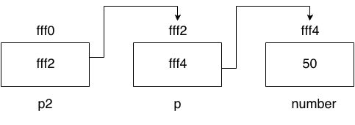

As you can see in the above figure, p2 contains the address of p (fff2) and p contains the address of number variable (fff4).

1. #include <stdio.h>
2. #include <conio.h>
3. **void** main(){
4. **int** number=50;
5. **int** *p;//pointer to int
6. **int** **p2;//pointer to pointer
7. clrscr();
8. p=&number;//stores the address of number variable
9. p2=&p;
11. printf("Address of number variable is %x \n",&number);
12. printf("Address of p variable is %x \n",p);
13. printf("Value of *p variable is %d \n",*p);
14. printf("Address of p2 variable is %x \n",p2);
15. printf("Value of **p2 variable is %d \n",**p);
17. getch();
18. }

#### Output

Address of number variable is fff4

Address of p variable is fff4

Value of *p variable is 50

Address of p2 variable is fff2

Value of **p variable is 50

# Pointer Arithmetic in C

In C pointer holds address of a value, so there can be arithmetic operations on the pointer variable. Following arithmetic operations are possible on pointer in C language:

* Increment
* Decrement
* Addition
* Subtraction
* Comparison

## **Incrementing Pointer in C**

Incrementing a pointer is used in array because it is contiguous memory location. Moreover, we know the value of next location.

Increment operation depends on the data type of the pointer variable. The formula of incrementing pointer is given below:

1. new_address= current_address + i * size_of(data type)

#### 32 bit

For 32 bit int variable, it will increment to 2 byte.

#### 64 bit

For 64 bit int variable, it will increment to 4 byte.

Let's see the example of incrementing pointer variable on 64 bit OS.

1. #include <stdio.h>
2. **void** main(){
3. **int** number=50;
4. **int** *p;//pointer to int
5. p=&number;//stores the address of number variable
7. printf("Address of p variable is %u \n",p);
8. p=p+1;
9. printf("After increment: Address of p variable is %u \n",p);
10. }

#### Output

Address of p variable is 3214864300

After increment: Address of p variable is 3214864304

## **Decrementing Pointer in C**

Like increment, we can decrement a pointer variable. The formula of decrementing pointer is given below:

1. new_address= current_address - i * size_of(data type)

#### 32 bit

For 32 bit int variable, it will decrement to 2 byte.

#### 64 bit

For 64 bit int variable, it will decrement to 4 byte.

Let's see the example of decrementing pointer variable on 64 bit OS.

1. #include <stdio.h>
2. **void** main(){
3. **int** number=50;
4. **int** *p;//pointer to int
5. p=&number;//stores the address of number variable
7. printf("Address of p variable is %u \n",p);
8. p=p-1;
9. printf("After decrement: Address of p variable is %u \n",p);
10. }

#### Output

Address of p variable is 3214864300

After decrement: Address of p variable is 3214864296

## **C Pointer Addition**

We can add a value to the pointer variable. The formula of adding value to pointer is given below:

1. new_address= current_address + (number * size_of(data type))

#### 32 bit

For 32 bit int variable, it will add 2 * number.

#### 64 bit

For 64 bit int variable, it will add 4 * number.

Let's see the example of adding value to pointer variable on 64 bit OS.

1. #include <stdio.h>
2. **void** main(){
3. **int** number=50;
4. **int** *p;//pointer to int
5. p=&number;//stores the address of number variable
7. printf("Address of p variable is %u \n",p);
8. p=p+3;   //adding 3 to pointer variable
9. printf("After adding 3: Address of p variable is %u \n",p);
10. }

#### Output

Address of p variable is 3214864300

After adding 3: Address of p variable is 3214864312

As you can see, address of p is 3214864300. But after adding 3 with p variable, it is 3214864312 i.e. 4*3=12 increment. Since we are using 64 bit OS, it increments 12. But if we were using 32 bit OS, it were incrementing to 6 only i.e. 2*3=6. As integer value occupies 2 byte memory in 32 bit OS.

## **C Pointer Subtraction**

Like pointer addition, we can subtract a value from the pointer variable. The formula of subtracting value from pointer variable is given below:

1. new_address= current_address - (number * size_of(data type))

#### 32 bit

For 32 bit int variable, it will subtract 2 * number.

#### 64 bit

For 64 bit int variable, it will subtract 4 * number.

Let's see the example of subtracting value from pointer variable on 64 bit OS.

1. #include <stdio.h>
2. **void** main(){
3. **int** number=50;
4. **int** *p;//pointer to int
5. p=&number;//stores the address of number variable
7. printf("Address of p variable is %u \n",p);
8. p=p-3; //subtracting 3 from pointer variable
9. printf("After subtracting 3: Address of p variable is %u \n",p);
10. }

#### Output

Address of p variable is 3214864300

After subtracting 3: Address of p variable is 3214864288

You can see after subtracting 3 from pointer variable, it is 12 (4*3) less than the previous address value.